**Upcoming Author Visits**

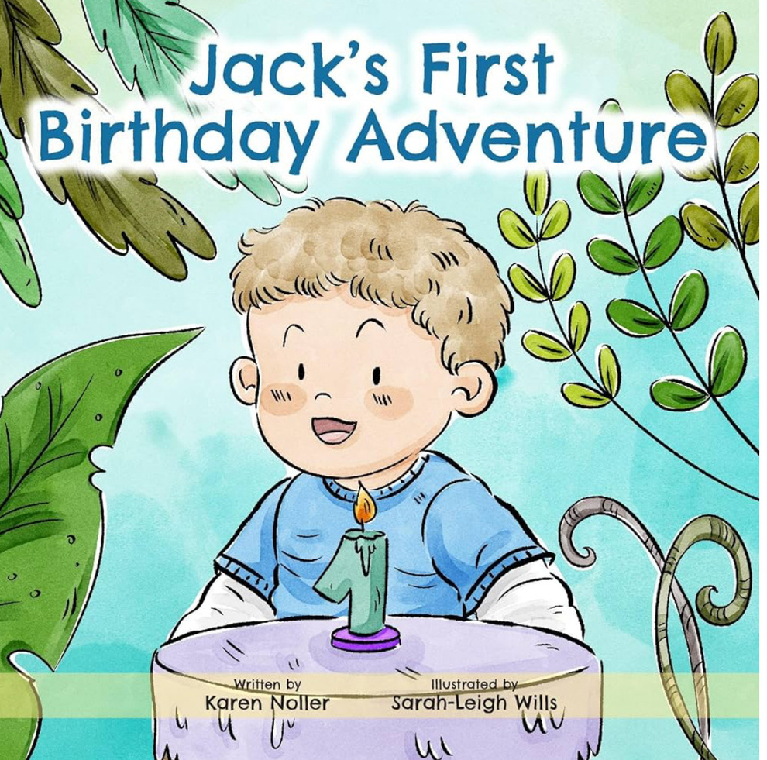

Looking forward to these visits in the Autumn Term. Where will I be on...?

1st October Crays Hill Primary School

16th October Great Wakering Primary Academy

6th November Great Waltham C of E (VC) Primary School

2025:

I’m all booked out for World Book Week (beginning 3rd March 2025) but get in touch via my Contact page if you would like to secure a Spring or Summer visit. Don’t delay ... book today!

Email: author@karennollerbooks.co.uk

